**CHAPTER 1**

**INTRODUCTION**

* 1. **Introduction**

Here, “Locate Restaurant:EDE(Eat Drink Enjoy)” has been designed to guide the visitors and general public people to locate the hotels and restaurants with their details profiles situated in our beautiful city “Biratnagar”.

Locate Restaurant:EDE is a mobile based application as well as location based application which can be significantly used to locate the nearby restaurants in Biratnagar. It is quite simple enough to use, as a simple concept of GUI framework has been incorporated. It helps the users to get information about the location and services granted by the desired particular restaurant. This application fetches the information about the particular restaurant by online mode.

The online mode provides the services for users to search by clicking the “Find Hotel” button which than triggers the Google map. Furthermore, online mode can also be used to view and locate the locations nearby and also the tracks to get the desired destination venue. [1] → (This is the sample for providing the reference / citation).

* 1. **Problem Statement:**

For someone who was in an uncomfortable place or in a crowd, then to know and locate dining places that are in our surrounding in not as easy as we consider. With the rapid growth of technology, this difficulty can be settled. We can easily find the dining places that are around us only with the help of smart phones that we always carry.

With the advent of mobile and handheld devices as well as prolific development in the android, users have been gone app centric. Although, there are many applications designed to offer the services it is flooded with information and users needed internet connectivity to get the basic information. After all, here are no such applications that are being designed and developed for specific location to help the local people as well as visitors who visit Biratnagar and want to search for the nearby restaurants with their services.

In spite of lots of several apps in the Google play store, we decided to build up new app with the motto and ambition of local information distribution.

* 1. **Objectives:**

The summary of the objective of this mobile application is:

* To facilitate users with blood instantly.
* To
  1. **Scope and Limitations:**

## **1.4.1** **Scope:**

This application will have the widest range of scope. Some of them are listed as follows:

* Storage of the information about the locations of restaurant.
* Promoting restaurant business.
* User can navigate the route using Google maps to find nearby restaurants.
* Users can get the information with internet.

**1.4.2 Limitation:**

This application is not free of limitations. Some of them are listed as follows:

* The application runs on android operating system.
* This application will not be able to retrieve online information of all the places in Nepal but just around the particular city.
* This application will not be able to retrieve online information that has been updated by the businesses instantly.

**1.5 Report Organization:**

On completion of our project development, we have documented the milestones and the final document report has been organized under the following chapters:

Chapter 1: Introduction

Chapter 2: Requirement Analysis and Feasibility Analysis

Chapter 3: System Design

Chapter 4: Implementation and Testing

Chapter 5: Maintenance and Support

Chapter 6: Conclusion and Recommendation

**First chapter** consists of a brief introduction about our project title giving a broad idea about the idea behind our project and a problem definition. It also consists of the objectives, scope, limitation regarding the project.

**Second chapter** consists of a literature review giving a short description about the papers and articles that we have gone through. It also consists of the use case diagram defining the functional requirements of the system, a feasibility analysis describing the economical, technical and operational feasibility of the system and a Gantt chart describing the time that was taken to achieve the different tasks.

**Third chapter** describes the details of the system through the interface design, input output design and process design. It also includes System Interface Diagram and Flowchart.

**Fourth chapter** contains the information about the implementation tools used, different types of testing done and test cases used to test the developed system.

**Fifth chapter** consists of the description of the strategies that can be used to provide maintenance and support for the software that can be used after the system has been implemented.

**Sixth chapter** consists of the summary of the entire project and report and the things that we learnt on the completion of the project.

**CHAPTER 2**

**REQUIREMENT ANALYSIS & FEASIBILITY ANALYSIS**

**2.1 Background Study**

The main focus of our research for the project was the restaurants as well as the visitors in Biratnagar. It was found that the people were finding and facing difficulties in going to restaurant because of lack of basic information about the restaurant. Besides, the numbers of smart phone users were higher which run on Android OS.

So, we decided to proceed our project in the android mobile application. Our aim to develop the project is to enable the users to find the best restaurant available near to their location and gain the basic information about the restaurant in online mode.

**2.2 Literature Review**

Review of related literature is the theory which the researchers use to explain the existence of research problems and can be taken from various books, journals, reports, etc.

The android applications similar to our Locate Restaurant application are as follows:

**1. A Restaurant Finder Application: FED**

“A Restaurant Finder Application: FED (Find Eat Drink)”is a mobile application system that manages and stores the details of the restaurants in our city Biratnagar, is a location-based service application.

Restaurant Finder mobile application has been designed to help the tourists and general people for finding the restaurants available near to their location. In this application, simple GUI has been incorporated that it makes very simple and easy for user to find the information related to location and services offered by the particular restaurant. This application also gives the information in the local areas offline. The offline mode gives the various descriptions and maps. A user can also search in online mode clicking on the “Go Online” button which then triggers the Google map. Online mode can be used to search and find the locations nearby and also the routes to get to the venue.

It is developed by the project team of Nihareeka students. It is an android app that helps users to locate the nearby hotels and restaurants. For someone who was in an unfamiliar place or in a crowd, then to know and find dining places that are in the surrounding is not easy. With the rapid growing of the technology, this problem can be resolved. We can easily find the dining places that are around us only with the help of smart phone that we always carry.

With the advent of mobile and handheld devices as well as development in the android, users have been app centric. Although there are applications designed to offer the services it is flooded with information and users needed internet connectivity to gain the basic information. Besides, there are no such applications that are being developed for specific location to help the local people as well as the tourists who visit Biratnagar and want to search for the nearby restaurants. Thus, this android mobile application “A Restaurant Finder Application: FED (Find Eat Drink)” is being designed and developed.

In spite of lots of apps in the Google store, it is developed with the motto of local information dissemination. Also, there are no such applications which can give the total information about the locally available restaurants with the maps and routes in offline mode. [1]

**2. OpenTable**

Use OpenTable to discover, explore, book, and manage restaurant bookings free and instantly—anytime, anywhere. As the global leader in restaurant bookings, OpenTable’s app helps you discover new restaurants; view menus, reviews, and photos; and earn reward points towards your next delicious meal.

OpenTable is developed by OpenTable International. The map can be a bit slow to access-by the time it loads you may have started accessing the phone-and it only shows OpenTable clients.

In addition to the 1+ BILLION diners it has seated at 40,000+ restaurants worldwide, others love OpenTable as well:

* OpenTable Is Secretly the Best Thing on the Internet (Gizmodo)
* World's Greatest Apps (Business Insider)
* Best Restaurant Booking Apps (The Telegraph)
* Top Android Developer (Google Play)

**Merits:**

* BOOK SIMPLY, INSTANTLY, and FREE at thousands of restaurants
* DISCOVER & RESEARCH restaurant reviews, photos, menus, and more
* SEARCH WITH EASE by preference: party size, date, time, cuisine, price, or distance
* GET SPECIAL OFFERS from restaurants
* GET REWARDED with points when you dine out and save on future meals
* MANAGE BOOKINGS on the go —it’s easy to change, cancel, and re-book
* COORDINATE PLANS with friends by sending OpenTable invitations and adding bookings to calendars
* TRAVEL READY to help you reserve restaurants in the United States, Canada, Mexico, United Kingdom, Ireland, Germany, Australia, Japan, and more. [2]

**3. Restaurant Finder**

Restaurant Finder offers a convenient way to find restaurants around you. You can search for restaurants nearby or type in an address or zip code.

If you are looking for restaurants, this app will find them for you. You don't even need to type anything.

Restaurant Finder works well worldwide but especially in USA, UK, Ireland, Canada, Germany, Italy, France, Spain, Denmark, India, Australia, Brazil, Malaysia and Thailand.

You can find restaurants nearby very easily by using the restaurants near me or "By current location" buttons. Alternatively, you can type the name of the restaurant or the address or zip code where you want to find food places.

You can view information about the restaurant such as opening hours, reviews, phone number and food menus.

Restaurant Finder can also be used to find Meal take away and delivery, cafes, pubs, hotels, night clubs, grocery stores and super markets, taxis and cabs, and gas stations. You can also see the food hygiene rating of a restaurant.

The Restaurants Near Me feature uses your current GPS location and displays a list of restaurants, if the Restaurants Near Me feature does not return any results, please make sure your location services are enabled or alternatively you can type your address in the search box.

Food Hygiene rating is available for UK food places only. Thus, this application can find the nearest restaurants just by using our location. [3]

**4. nLocate**

nLocate is your perfect tool that helps you trace the path of the places you visited recently. With this app installed on your device, you can wander not worrying about how you will reach your original location. Just tap in to add your current location, the place from where you start and trace it later from a different place to go back.

nLocate is a local search application for Nepal. It helps us to locate essential services like hospitals, ATMs, banks, petrol pumps, etc. [4]

**5. Nearby Places Finder**

Nearby Places Finder is a place searching app. Using Nearby Places Finder, you can easily locate the ATMs, Bus stand, hotels, hospital, school and many other places near you. Nearby Place Finder will itself locate your position by using GPS and on the basis of that, it will find your Places of Interests. Get detailed information of the place you want to go. Also, you can find the directions you have to follow to travel between any two places and find out shortest path. You just have to click the place you want to go.

Key Features of Nearby Places Finder are:

* Freely available
* GPS Supported
* 50+ Types of Place Supported
* Both Map View and List View
* Nice Interface
* Google Material Design guided
* Powered by Google
* Very lightweight
* Locate places easily.
* Get Directions to reach from one place to another.
* All Types of Map Supported
* Shortest path to reach their location

If you're planning a visit abroad and wish to seek out restaurants, hotels, ATMs, Banks or simply concerning something you'll be able to find easily with this app. [5]

**6. Gantabya Plus**

Gantabya Plus is a mobile application which helps users to find the effective route to travel inside Nepal (Currently Kathmandu) without requiring Internet data. It even finds the total distance, total cost and list of stations on that route.

Features:

* Find best possible route of public vehicle to travel inside Kathmandu which is fully offline.
* Get the fare, distance and stations information of searched route.
* If you find missing routes, you can even add routes which will be verified by gantabya plus team and update it
* More helpful modules like- Nearby places (requires internet), Discount calculator for student and old people, Emergency numbers.
* You can even send your feedback to make this application better and handy.

This app is like a local guide for people to make better plan while traveling in public vehicle.

If you like the app, there is a button to share it with your friends. This application is for finding the best possible route to travel in public bus inside Kathmandu. [6]

**2.3 Requirement Analysis**

Requirement collection plays a key role. Requirements collection is not only important for the project, but it is also important for the project management function.

For the project, understanding what the project will eventually deliver is critical for its success. Through requirements, the project management can determine the end deliveries of the project and how the end deliveries should address client’s specific requirements.

Requirements are basically two types. They are functional requirements and non-functional requirements.

**2.3.1 Functional Requirements**

Functional requirement is a requirement that defines specific behavior or functions. The plan for implementation of functional requirements is detailed in the system design. Broadly, functional define what a system is supposed to do.

The functional requirement of the application is as follows:

* Show the Find Hotel option
* Display the list of the restaurants
* Display the name of the restaurants
* Display the location of the restaurants via map

**Use Case Diagram**

Use case Diagram is a graphical depiction of the interactions among the elements of the system. A use case diagram consists of four main components:

* The boundary, which defines the system interest.
* The actors, usually individuals involved with the system defined according to the roles.
* The use case, which specific roles are played by actors within and around the system.
* The relationship between and among the actors and use-case.

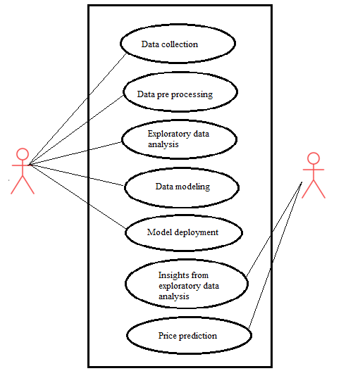

**Admin**

**User**

**Figure 1: Use Case Diagram for …………..**

**2.3.2 Non-functional Requirements**

A **non-functional requirement** is a requirement that specifies criteria that can be used to judge the operation of a system, rather than specific behaviors. Non-functional requirements are often called **qualities** of a system. Other terms for non-functional requirements are “constraints”, “quality goals”, “quality attributes”, “quality of service requirements” and “non-behavioral requirements”. The plan for implementing non-functional requirements is detailed in the system architecture.

Some non-functional requirements of this project are listed below:

* **Usability:** Every user can use this Application easily.
* **Efficiency:** This Application provides the information online.
* **Performance:** The users easily access without any effort as an organized way and this making the Application more reliable.

**2.4 Feasibility Analysis**

Feasibility studies is aimed to objectively and rationally uncover the strengths and weaknesses of an existing business or proposed venture, opportunities and threats present in the environment, the resource required to carry through and ultimately the prospects for success. Feasibility study is the process of determining whether or not a project is worth doing. The feasibility study helps us for deciding how to proceed the project.

Some of the feasibility studies include:

**2.4.1 Technical feasibility**

The systems project is considered technically feasible if the internal technical capability is sufficient to support the project requirements. In this project, Android studio technology is being used which is one of the mostly used technology. This Android studio is already proved as a technical feasible to develop a system.

**2.4.2 Operational feasibility**

Operational feasibility is a measure of how well a proposed system solves the problems and takes advantage of the opportunities identified during scope definition and how it satisfies the requirements identified in the requirements analysis phase of system development.

This project is operationally feasible as to execute the system we need an android mobile which is common to all and used by everyone in today’s world.

**2.4.3 Economic feasibility**

Economic analysis could also be referred to as cost/benefit analysis. It is the most frequently used method for evaluating the effectiveness of a new system. The system which is going to be developed does not require any additional hardware or software as the interface as this system is developed using the existing resources and technologies available more closely.

**2.4.4 Schedule feasibility**

Schedule is the estimation of duration of the project and work division for carrying out the project work. A project is said to be failed too long for completion or completed after its deadline. The following Gantt chart depicts the project activities:

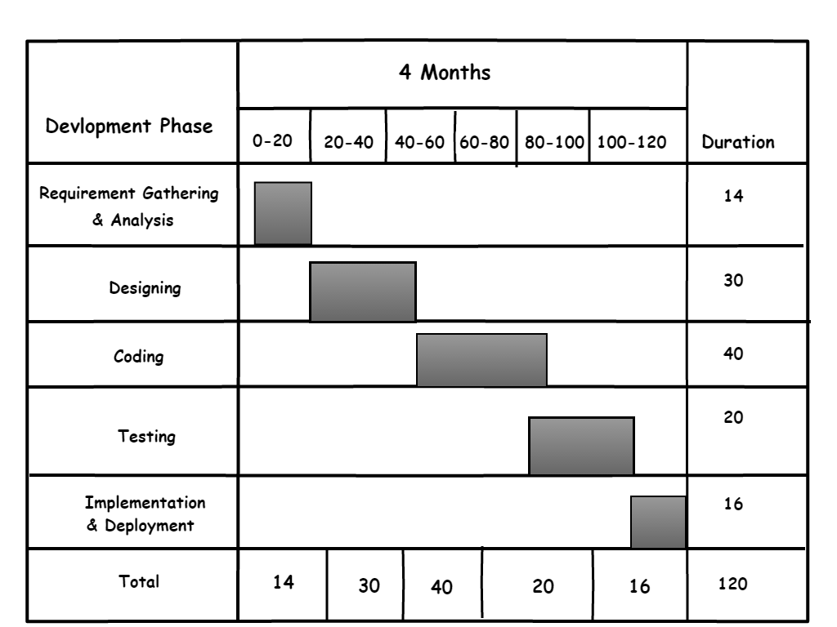**Table 1: Gantt chart**

**2.5 Structuring System Requirements**

Structuring system and database requirements concentrate on the definition, structure and relationships within data. The characteristics of data captured during data modeling are crucial in the design of databases, programs, computer screens and printed reports. This information is essential in ensuring data integrity in an information system.

**2.5.1 Data Modeling**

Data modeling is the process used to define and analyze data requirements needed to support the business processes within the scope of corresponding information systems in organization. The end result of the data modeling process is data model. The data model presents the logical organization of data without indicating how the data are stored, created, or manipulated so that analysis can focus on the business without being distracted by the technical details.

**ER-Diagram**

The most commonly used data modeling technique is ER-Diagram. It shows the relationship among the entities, having their respective attributes in the form of diagram.

The ER-Diagram for the mobile application developed is shown in the Figure 3.

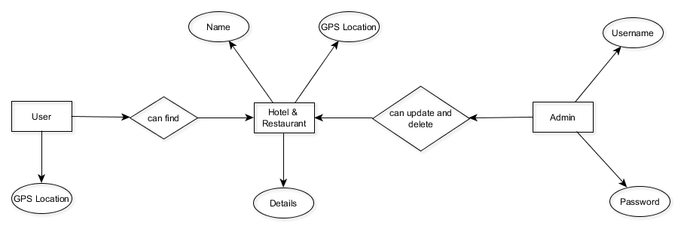

**Figure 3: ER-Diagram of Locate Restaurant Application**

**Class Diagram**

The most appropriate method of data modeling in case of Object-Oriented Programming (OOP) is class diagram.

The class diagram describes the structure of a system by showing the system's classes, their attributes, operations (or methods), and the relationships among objects.

The class diagram for this system is shown in the below Figure 4.

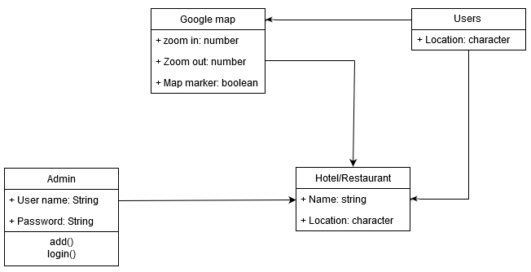

**Figure 4: Class Diagram of Locate Restaurant Application**

**2.5.2 Process Modeling**

Process model is a representation of reality that can be built for existing systems as a way to better understand those systems or for proposed systems as a way to document business requirement or technical designs. In other words, we can explain it as the process that represents how a system needs to operate.

In other words, graphical representation of the processes that capture, manipulate, store and distribute data between a system and its environment among system components is known as process modeling.

**Activity Diagram**

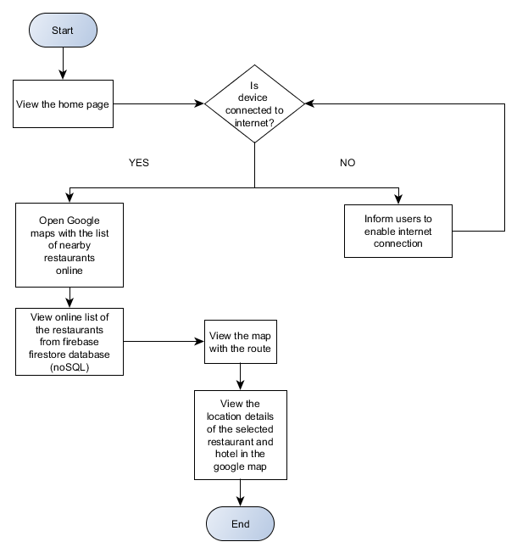

**Figure 5: Activity Diagram**

**CHAPTER 3**

**SYSTEM DESIGN**

**3.1 System Design**

This document contains the overall design of the system. The design of the system needs to cover all the effective measures so that to provide user the friendly environment for processing the task, as well to transform the transaction done as the real time processing. System architecture carries the structure and behavior of the system. Locate Restaurant application carries out the 3-tier architectural system defined as follows:

**User Interface**

**Application**

**Database**

**Figure 6: System Interface**

**User Interface:** User Interface is one of the major components that manage the interaction between human and machine. The user interface manages the interaction with the user. User Interface is responsible for:

* Shows guideline
* Shows list
* View Map
* Detail view

**Application:** Application layer handles all the business logic and data processing before storing data and viewing data, searching particular restaurant.

**Database:** A database is a collection of information that is organized so that it can be easily accessed, managed and updated.

The online data is fetched from firebase firestore database called **noSQL** within the Google map.

**3.1.1 Interface Design**

The overall structure of the application is relatively simple as shown in the following diagram.

The numbers in the diagram provide a reference to the individual screens described in this report.

1. Application
   1. Main Page
      1. Find Location

* + - 1. Google Map
      2. Nearby  
         Restaurant

* + - 1. Routes

1.2 Exit

**Figure 7: Interface Design**

The user interface has been designed to provide the user with an easy and friendly interface to interact with the system with as minimum effort as possible. The user interface can be designed in a way that the user can easily input the records through simple forms and can view the records or get the output only through a few clicks.

**3.1.2 Process Design**

**Flowchart:**

A flowchart is a formalized graphic representation of a logic sequence, work or manufacturing process, organization chart, or similar formalized structure. The purpose of a flow chart is to provide people with a common language or reference point when dealing with a project or process.

Flowcharts are used in designing and documenting simple process or programs. They help to visualize what is going on and thereby help understand a process, and perhaps also find flaws, bottlenecks, and other less-obvious features within it.

The flowchart of the application is as shown in the below figure 8:

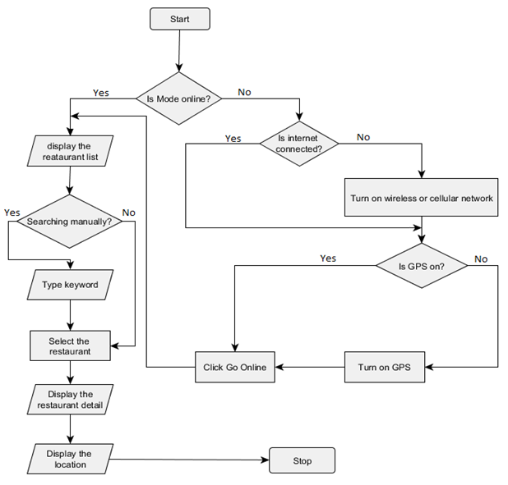

**Figure 8: Flowchart**

**CHAPTER 4**

**IMPLEMENTATION**

**4.1 Tools Used**

**(1) Android Studio:**

Android Studio is Android's official IDE for android application development. It is purpose built for Android to accelerate your development and help you build the highest-quality apps for every Android device. This project is developed by using android studio of version 3.1.4 which is the most popularly used version. This platform is the most efficient and quite easy for developing android apps. The Android Studio provides the underlying functionality to build variants and multiple APK file generation. All applications developed under the android studio applications, have certain key feature that ensure compatibility, security, and stability.

**(2) Firebase:**

Firebase is a mobile and web app development platform that provides developers with a plethora of tools and services to help them develop high-quality apps, grow their user base, and earn more profit. Firebase is a platform that makes developing android apps easier. It is owned by Google and is easy to integrate to your project.

**(3) yEd Graph Editor:**

**yEd** is a powerful desktop application that can be used to quickly and effectively generate high-quality diagrams. It focuses on either create diagrams manually, or import your external data for analysis. Our automatic layout algorithms arrange even large data sets with just the press of a button. yEd is freely available and runs on all major platforms: windows, Unix/Linux, mac OS.

**(4) draw.io**

djiszjf

**CHAPTER 5**

**MAINTENANCE AND SUPPORT**

**5.1 Maintenance**

After the application is built and is delivered to user, a frequent updating and maintenance is required. Once installed, appropriate maintenance and updating can be provided to the application as the application is made more users friendly.

**5.1.1 Adaptive Maintenance**

This application works on and can be implemented on the entire android version. The software is made compatible from android versions: Lollipop (5.0 – 5.1.1), Marshmallow (6.0 – 6.0.1), Nougat (7.0 – 7.1.2), Oreo (8.0 – 8.1.0). (note: if your project of case study is a web-based application, then test for the for the compatibility of different types of browsers with their different versions).

**5.1.2 Corrective Maintenance:**

Although the system has been analyzed different unexpected errors can arise. So, the errors can be fixed by frequent updating of the application.

**5.1.3 Perfective Maintenance:**

The application can be used in various platforms and furthermore it can be customized by adding new features depending upon the user’s requirement. The time required to customize the application will depend upon the user’s requirement and nature of the feature requested.

**5.2 Support:**

Support involves providing help or advice to the user encountering difficulties while using the application. The support can be provided to the user after the installation of the application. Support involves the following criteria:

* In case of any errors during the operation of the application, frequent update of the application is provided.
* Providing the appropriate information regarding the use of application.
* In case of not fulfillment of any user expectation in application, solving the problem is done through contacting the user through emails or messages.

**CHAPTER 6**

**CONCLUSION AND RECOMMENDATION**

**6.1 Conclusion:**

It has been a matter of immense pleasure, honor and challenge to have this opportunity to take up this project and complete it successfully. The project is designed to meet the requirements of the local people as well as the tourists who visit Biratnagar and needs the restaurants even if he/she is offline. Software has been developed to meet the above-mentioned requirements using XML and JAVA and Firebase (NoSQL) as an alternative database.

For designing the system, we have used simple data-flow diagrams.

The entire project development process teaches us the following skills:

* Using system analysis and design techniques like activity and interface diagrams in designing the system.
* Understanding the database handling.
* Group working/ Team working skills.
* We have learnt about the restaurants located in Biratnagar.
* We learnt to analyze a problem from the user's point of view and how to make it user-friendly by hiding its complications behind the transaction.
* It was a great help for us to understand and analyze our self-skills and interest that will be helpful for us to choose our field in future.
* We studied carefully and understood the criteria for making application more demanding.
* We realized the importance of maintaining a minimal margin for error.

**6.2 Recommendation:**

This project is designed by focusing on the users who may or may not have the internet access inside Biratnagar who wants to search for the list of the nearby restaurants found locally. This project can be further developed by enhancing additional features to it.

If the following considerations are done, then the project can have highly commercial scope and can be sold to many of the hotels:

* Online database can be extended.
* Application can be more extended and extensively developed to enhance the interface.